**COMMONWEALTH SECONDARY SCHOOL**

**Subject Combination Option User Guide for NA/NT**

**URL: https://commonwealth.schoolhub.sg**

## Log in

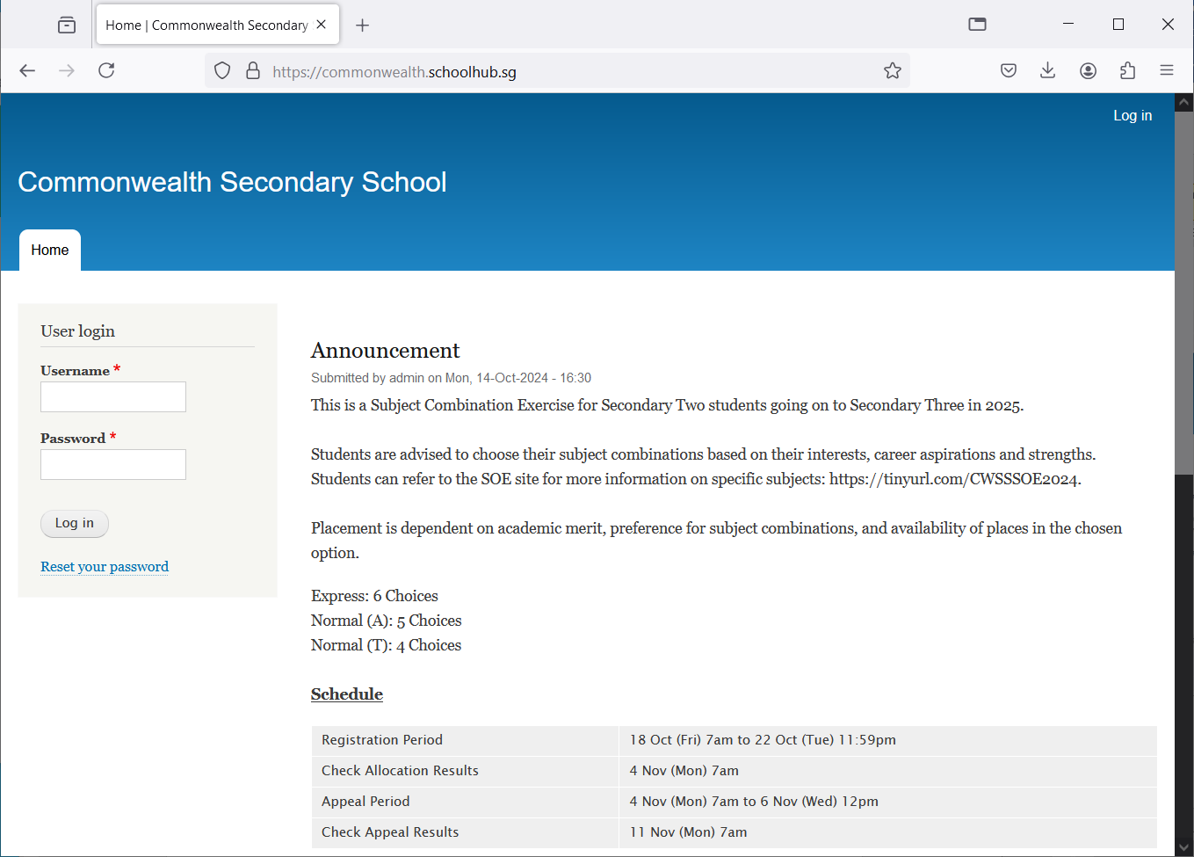

Steps

* Enter Username
* Enter Password
* Click on Log in button

## Main Menu

Upon Successful login, you will see the main menu

Update your Account

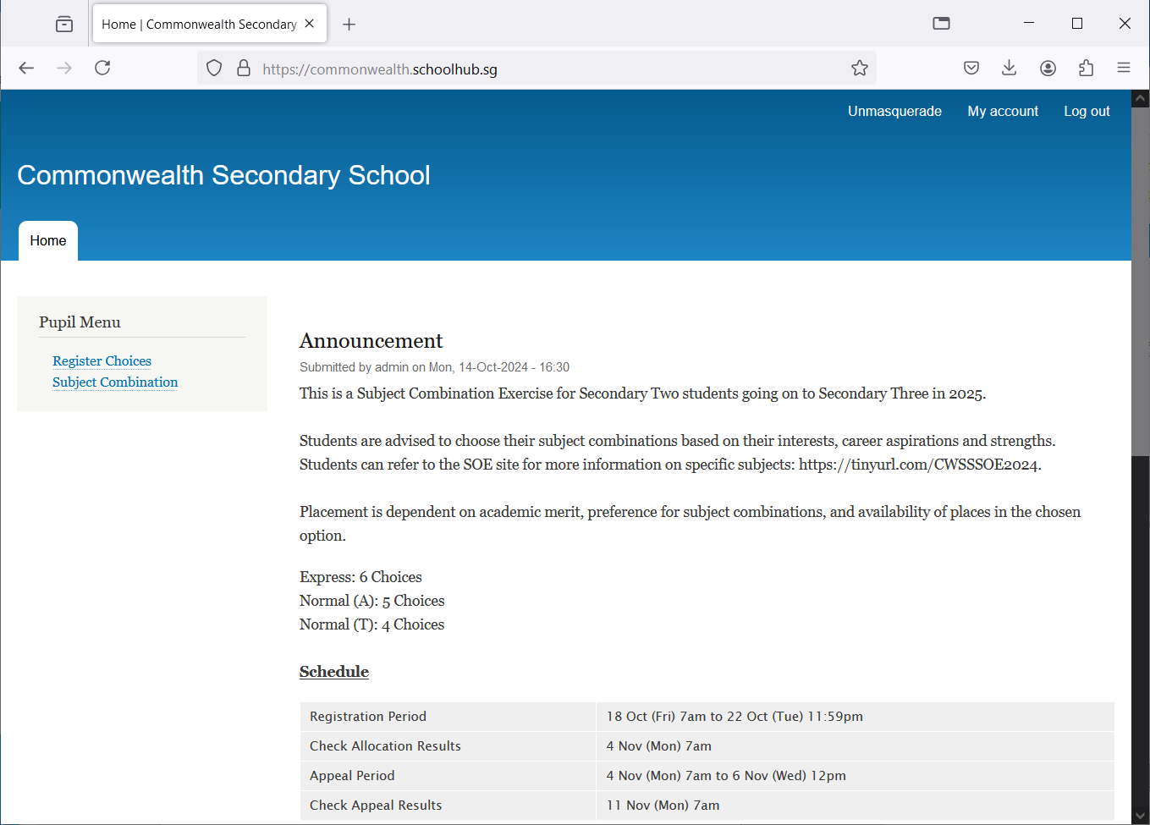

Update your choices

View all Subject Combinations

All Announcements will be posted here.

## Update User Account

This is Optional. You may change your password and update your email before you proceed to your Subject Combination choices.

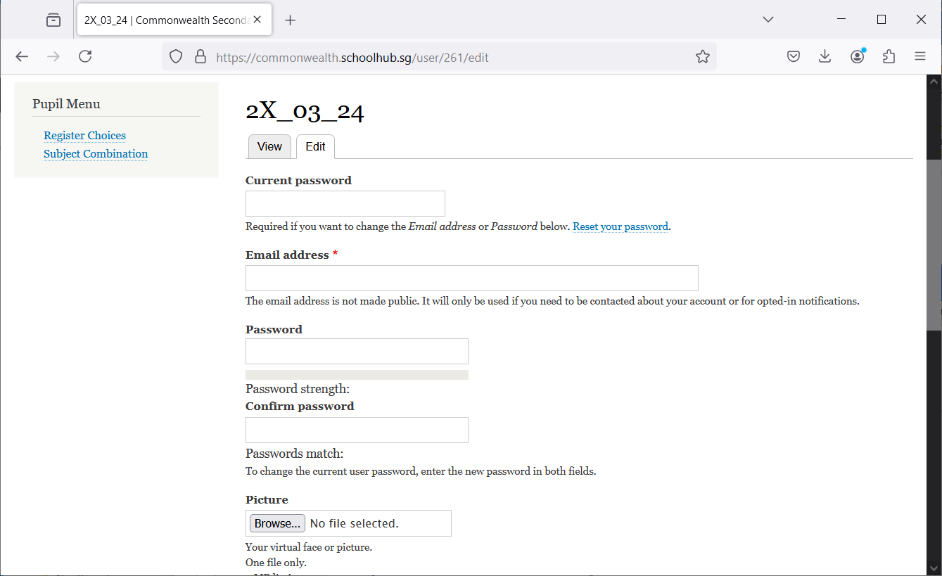

Steps

* Enter current password
* Update email address
* Enter New Password (leave blank if you want to retain current password)
* Click on Save button

## View Subject Combination

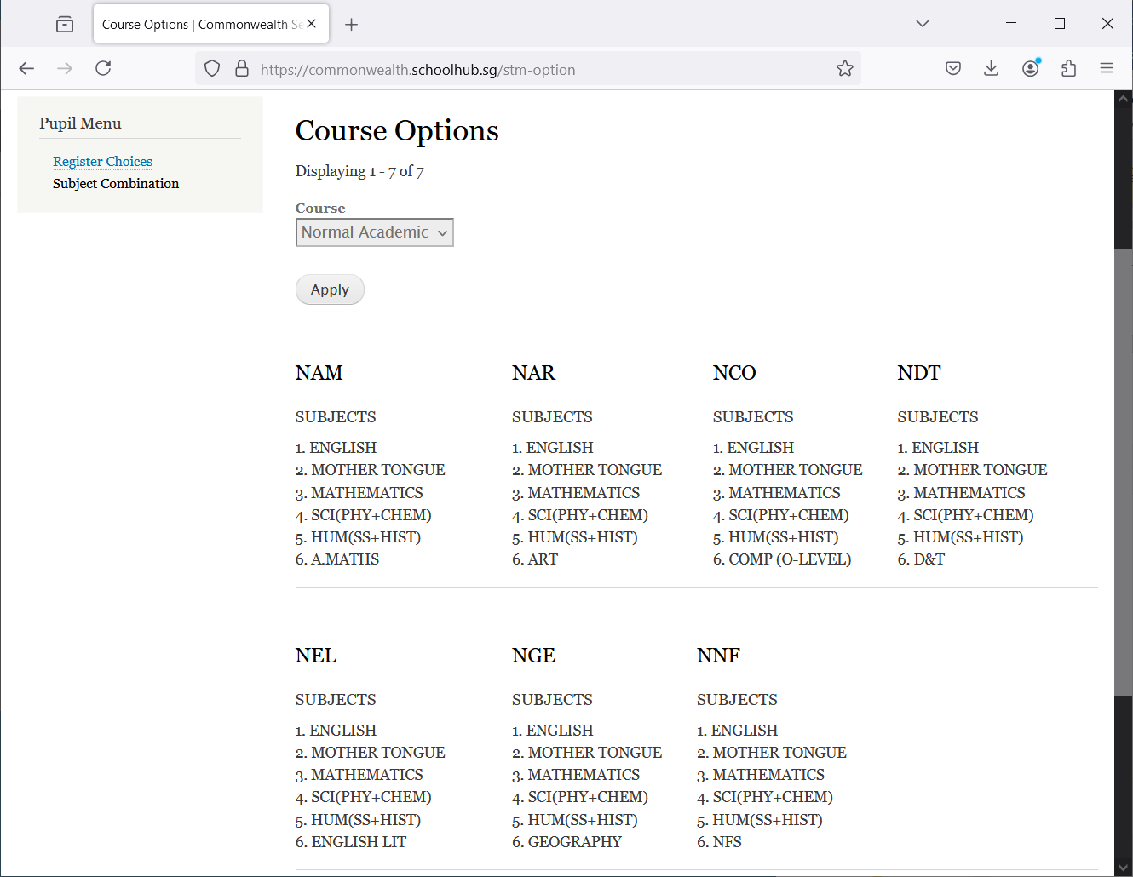

View Subject Combinations

## Registration of Choices

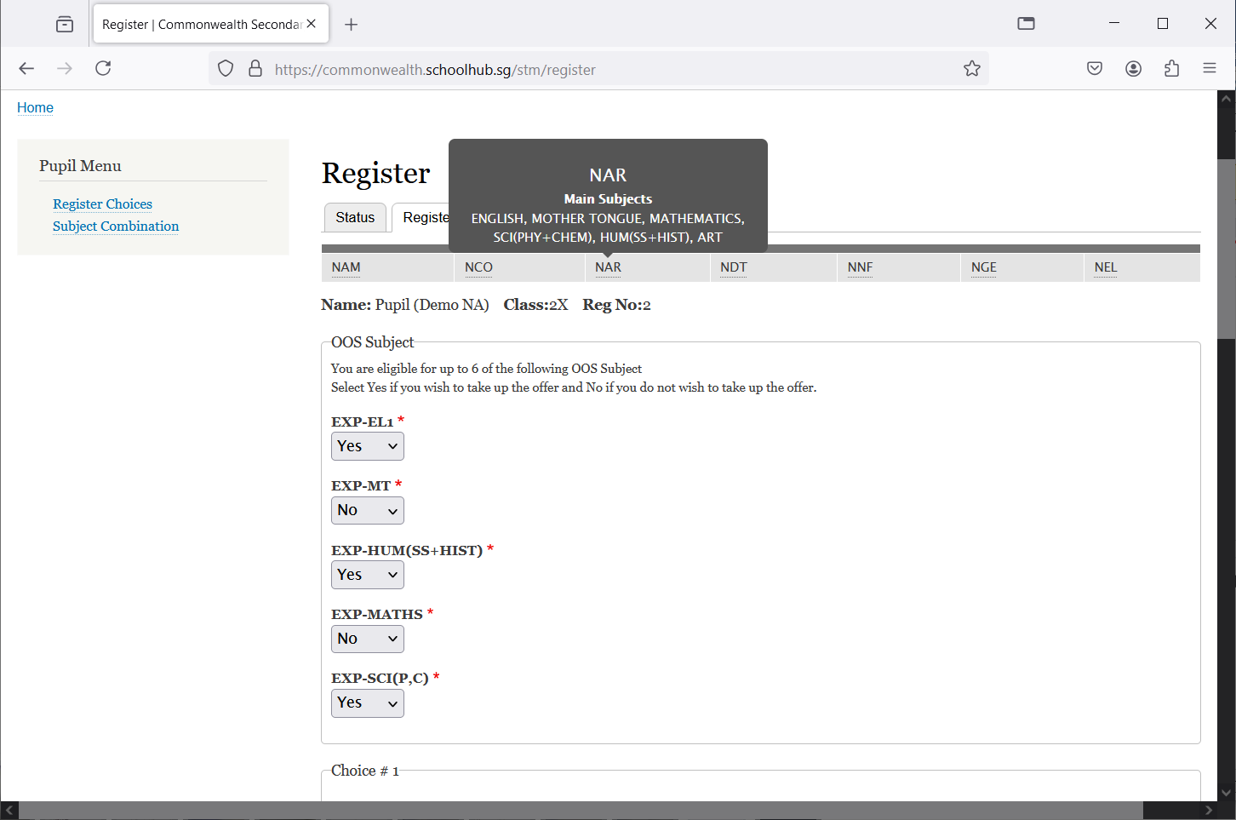

Click Register Choices

These are the list of Options you may choose from

You may Mouse-Over to view the Subject Combination

These are OOS Subjects Offer to you

Steps

* Click on Registration
* Update Your choices

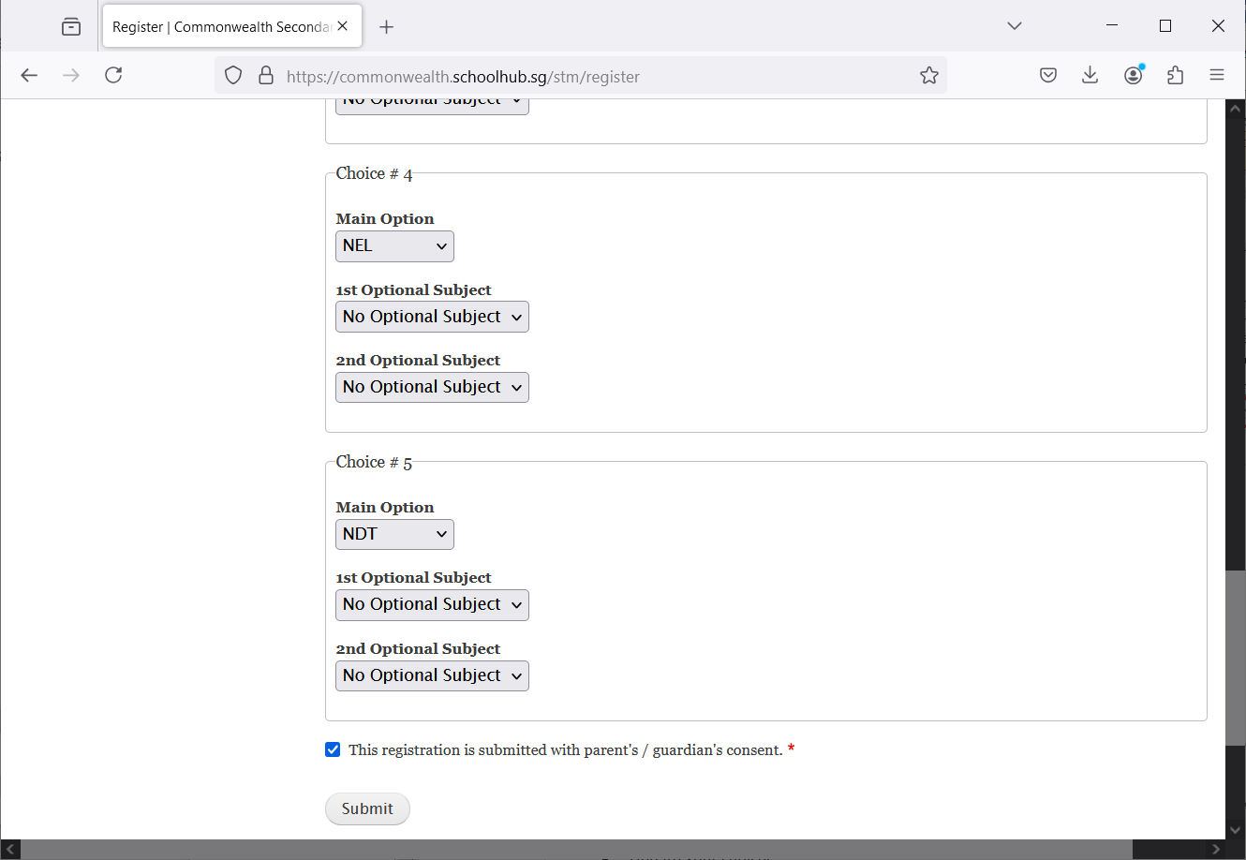

Tick this box before you Submit

Click Submit

Steps

* Tick the box “This registration is submitted with parent's / guardian's consent.”
* Click Submit Button

Note:

You may change your choices any time before the closing date.

## 

## Print Confirmation Slip

Once you have Submit Successfully, you may proceed to Print the Confirmation Slip.

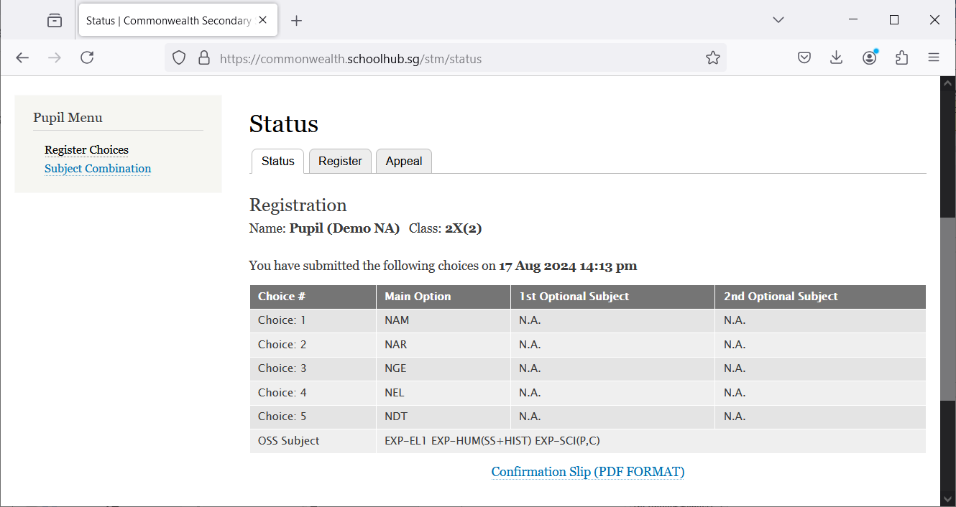

Steps

Print Confirmation Slip

* Click on Print Confirmation Slip (PDF Format)

**Sample Confirmation Slip**

