**COMMONWEALTH SECONDARY SCHOOL**

**URL: https://commonwealth.schoolhub.sg**

## Check Allocation

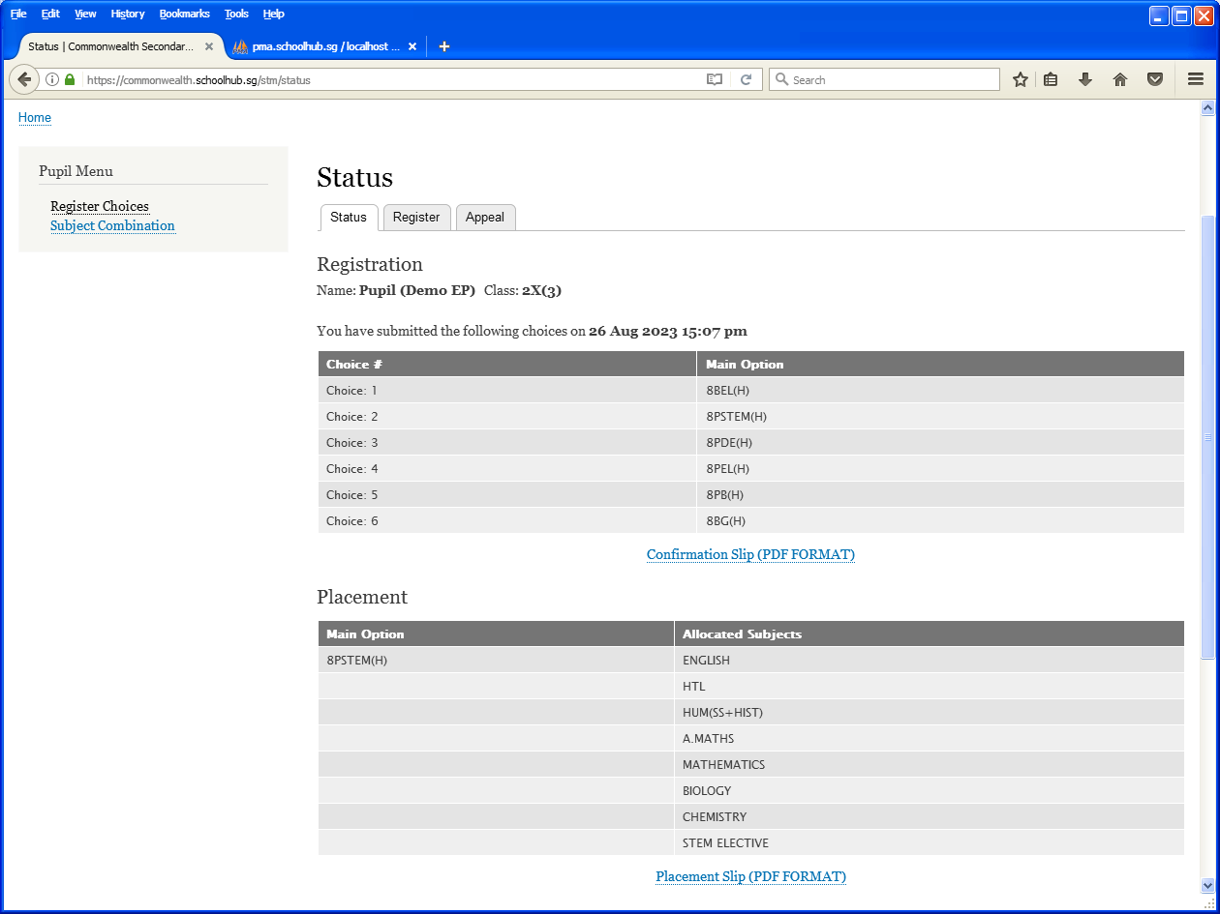

Click Register Choice

Allocated Option

Allocated Subjects

## APPEAL

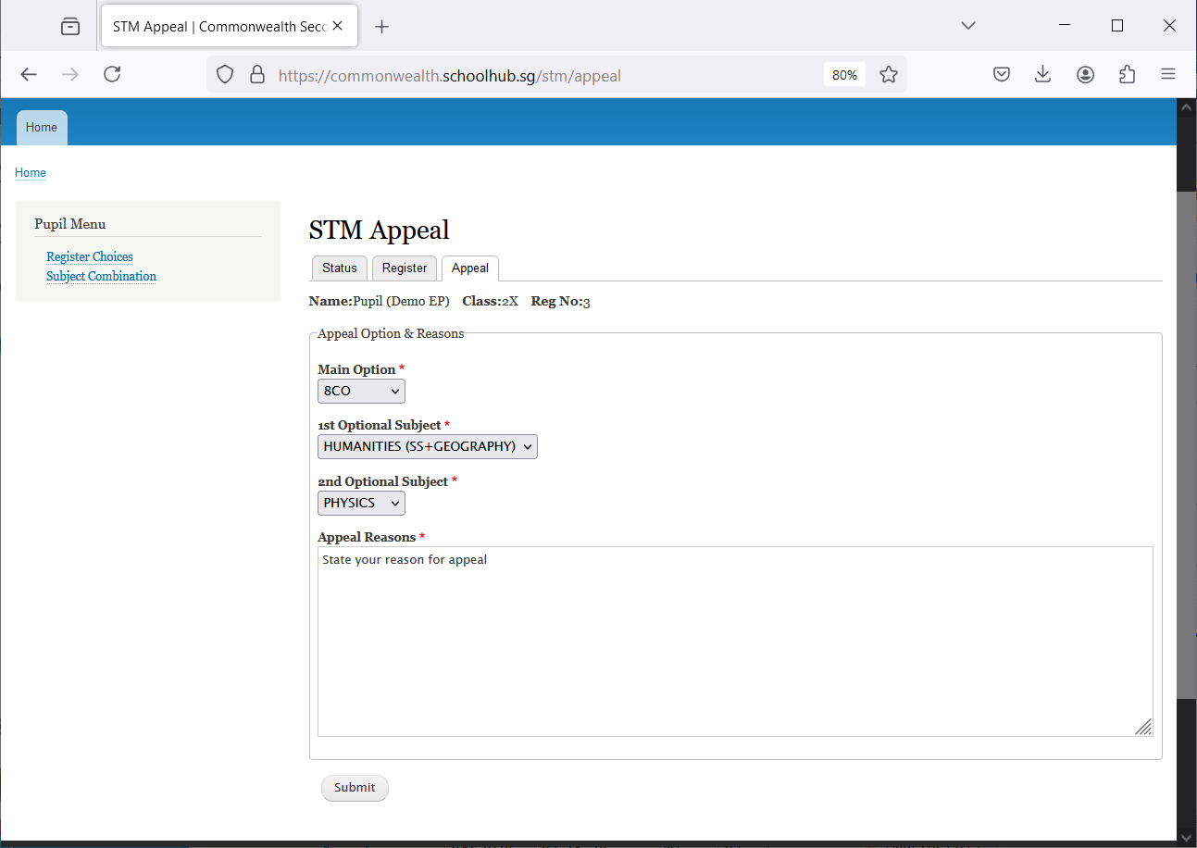

Indicate the reason for the Appeal

Enter Option to Appeal

Click Appeal

Click Submit

Steps

* Click on Student Option
* Click Appeal Tab
* Update your Appeal
* Click Submit at end of screen

Note:

You may change your Appeal any time before the Appeal Closing Date.